**DEV SKWAD 2020**

**ABOUT THE PROGRAMME**

The Dev Skwad represents the dynamic age at which young minds begin to blossom. It is the age at which young learners begin to form inquisitive mind-sets, and begin to explore the world around them in much keener detail.

Our objective is to encourage the young learners to explore, and spark their interest in technology by demonstrating to them that it’s never too early to get tinkering!

Through the Dev Skwad programme, young learners will be immersed in the world of programming, through a series of interactive courses aimed at introducing them to the world of technology. Furthermore, the programme ensures the young learners get an all-rounded experience by incorporating sessions by professionals in tech industries and trips to technology hubs and tech spaces, for practical and experiential learning.

The curriculum is designed such that each stage is delivered within one school year (2 terms effectively), to allow for a seamless integration with the national school system.

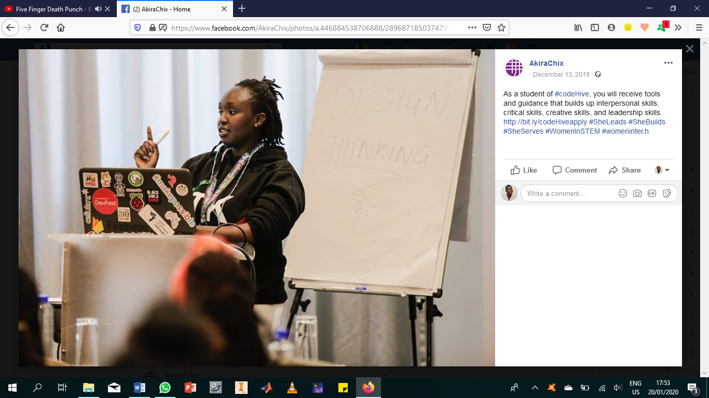

|  |  |
| --- | --- |
| Programme Duration | 3 years |
| Lesson Time | **2 hours per week** |
| Requirements | **A computer**  **+**  **An eager mind** |

**THE CURRICULUM**

|  |  |  |  |  |  |  |  |  |  |  |
| --- | --- | --- | --- | --- | --- | --- | --- | --- | --- | --- |
|  |  | | | | | | | | | **Extras** |
| **Beginner** | **Week** | **1** | **2** | **3** | **4** | **5** | **6** | **7** | **8** | Field Visits to local tech companies  Showcase events across different schools  Mentorship sessions by experts in industry |
|  | Intro to Computers  Navigating your computer | Basics of Scratch | In-depth Scratch Programming | | | Hero Talk: Session by someone in industry | Building: Project with Scratch  Turtle Stitch | |
|  | **Week** | **9** | **10** | **11** | **12** | **13** | **14** | **15** | **16** |
|  |  | Introduction to Application development using App Inventor  S4A | | Navigating your journey | In-depth App-Inventor App development  S4A | | | | Show-and-Tell: Presentations & Pitches |

|  |  |  |  |  |  |  |  |  |  |  |
| --- | --- | --- | --- | --- | --- | --- | --- | --- | --- | --- |
|  |  | | | | | | | | | **Extras** |
| **Intermediate** | **Week** | **1** | **2** | **3** | **4** | **5** | **6** | **7** | **8** | Experience sharing and coaching from university students  Cool merchandise, gifts, awards and certificates |
|  | Introduction to HTML / CSS | In-depth HTML / CSS Programming | | | Hero Talk: Session by someone in industry | In-depth HTML / CSS Programming | | |
|  | **Week** | **9** | **10** | **11** | **12** | **13** | **14** | **15** | **16** |
|  |  | Navigating your journey | Building:  Practical environment – based project with HTML / CSS | | | | | | Show-and-Tell: Presentations & Pitches |

|  |  |  |  |  |  |  |  |  |  |  |
| --- | --- | --- | --- | --- | --- | --- | --- | --- | --- | --- |
|  |  | | | | | | | | | **Extras** |
| **Advanced** | **Week** | **1** | **2** | **3** | **4** | **5** | **6** | **7** | **8** | Opportunities for student trips abroad  Opportunities to participate in global tech events |
|  | Introduction to Python | Basic Text & Data Manipulation | | Tinkering with Graphics | | Hero Talk: Session by someone in industry | Game Development with Python | |
|  | **Week** | **9** | **10** | 11 | 12 | 13 | 14 | 15 | 16 |
|  |  | Game Development with  Python | | | Navigating your journey | Building: Practical project using Python | | | Show-and-Tell: Presentations & Pitches |